

ASSET VERIFICATION AND RECORDING TOOL KIT


Plot 31, Bukoto Street
P.O Box 7657, Kampala, Uganda
+256 (0) 39 2000216/0772525235
email: cpa@cpa.ug

www.cpa.com

August to September 2026

SCHOOL VERIFICATION CHECKLIST

SCHOOL INTERVIEW/DISCUSSION GUIDE

Name of school: …ST ANDREWS NDWADDEMUTWE SEED SECONDARY SCHOOL…………

1a | Does the Facility have a record of all assets provided under UgIFT.  (Obtain a record and verify if it has the costs and numbers supplied | Yes
1b | If Not ask how many were supplied and when.

2 | How does this facility Maintain (repair/service/replace) the assets provided under Ugift? No

3 | Does the facility take regular record about functionality/ or breakdown of the assets provided?  Nonfunctional/ working, and reasons for non-functionality. | No

4 | How has the UgIFT support helped in service delivery in the area, any issues, challenges and any recommendations for better program implementation.

PROCEED TO VERIFICATION AFTER THIS DISCUSSION

SCHOOL FURNITURE
(School Desks, Office chairs, Laboratory stools, Book shelves)

Name of LG…MUKONO DISTRICT LOCAL GOVERNMENT… Name of SCHOOL… ST ANDREWS NDWADDEMUTWE SEED SECONDARY SCHOOL …

Equipment/ Item | Department | Asset Number | Item  Description | Life in Months | Tag Number ( engrave no.) | Date Of Pur | Date Placed In Service | Recoverable cost | Cost | Acc Dep Cost | Net Book Value | Ytd Deprn | Equipment status | Remarks
Desks | Classroom blocks |  | Wooden |  | Not engraved |  |  |  |  |  |  |  | Functional | 120 were received. School asset register doesn’t indicate costs & dates when equipment was purchased and placed in service.
Students Chairs | Classroom blocks |  | Wooden |  | Not engraved |  |  |  |  |  |  |  | Functional | 280 were received . School asset register doesn’t indicate costs & dates when equipment was purchased and placed in service.
Laboratory Stools | ICT/Science block |  | Wooden with metallic stands |  | Not engraved |  |  |  |  |  |  |  | Functional | 190 were received. School asset register doesn’t indicate costs & dates when equipment was purchased and placed in service.
Tables | Administration, |  | Wooden |  | Not engraved |  |  |  |  |  |  |  | Functional | 90 were received. School asset register doesn’t indicate costs & dates when equipment was purchased and placed in service.
Office Tables | Administration, ICT |  | Wooden with 4 drawers. |  | Not engraved |  |  |  |  |  |  |  | Functional | 15 were received. School asset register doesn’t indicate costs & dates when equipment was purchased and placed in service.
Laboratory Stools | Computer, ICT & science laboratory |  | Wooden seats with metallic stands |  | Not engraved |  |  |  |  |  |  |  | Functional | 190 were received. School asset register doesn’t indicate costs & dates when equipment was purchased and placed in service.
Book Shelves | Library |  | Wooden |  | Not engraved |  |  |  |  |  |  |  | Functional | 10 were received. School asset register doesn’t indicate costs & dates when equipment was purchased and placed in service.

ICT ITEMS TO VERIFY
(Desktop Computer, Server Processor, Network Switch 24 Port, Multipurpose Printer, UPS, Projector, Air Conditioners, Server, CCTV Camera)

Name of LG…MUKONO DISTRICT LOCAL GOVERNMENT…Name of SCHOOL…ST. ANDREWS NDWADDEMUTWE SEED SECONDARY SCHOOL……

Equipment/item | Department | Asset number | Item description | Life in months | Tag Number | Date of Purchase | Date Placed in Service | Recoverable cost | Cost | Acc Dep cost | Net Book value | Ytd Deprn | Equipment status | Remarks
COMPUTER SET | COMPUTER LAB |  | Hp |  |  |  |  |  | 2,259,000 |  |  |  | Functional | Received 28. School asset register doesn’t indicate when equipment was purchased and when it was placed in service
CPU | COMPUTER LAB |  | L600  LUMINOUS |  | MoES/UGIFT/KIMENYEDDE SEED S.S 001- MoES/UGIFT/KIMENYEDDE SEED S.S 028- |  |  |  |  |  |  |  | Functional | Received 28. School asset register doesn’t indicate when equipment was purchased and when it was placed in service
MONITOR | COMPUTER LAB |  | HP |  | MoES/UGIFT/KIMENYEDDE SEED S.S 001- MoES/UGIFT/KIMENYEDDE SEED S.S 028- |  |  |  |  |  |  |  | Functional | Received 28. School asset register doesn’t indicate when equipment was purchased and when it was placed in service
UPS | COMPUTER LAB |  |  |  | MoES/UGIFT/KIMENYEDDE SEED S.S 005
HP PRINTER | SECRETARYS OFFICE |  | HP Office Jet Pro 8745 |  | Not engraved |  |  |  | 4,900,000 |  |  |  | Functional | Received 1. School asset register doesn’t indicate when equipment was purchased and when it was placed in service
PROJECTOR | HEADMASTERS OFFICE |  |  |  | Not engraved |  |  |  | 2,150,000 |  |  |  | Functional | Received 1. School asset register doesn’t indicate when equipment was purchased and when it was placed in service

BUILDINGS TO VERIFY
(Non- Residential and Residential, Kitchen, Toilets/Pit latrine Water tanks, Fences etc.)

Name of LG…MUKONO DISTRICT LOCAL GOVERNMENT… Name of SCHOOL…ST ANDREWS NDWADDEMUTWE SEED SECONDARY SCHOOL………

Equipment/ Item | Department | Asset Number | Item  Description | Life in Months | Tag Number ( engrave no.) | Date Of Pur | Date Placed In Service | Recoverable cost | Cost | Acc Dep Cost | Net Book Value | Ytd Deprn | Equipment status | Remarks
Multi- Purpose block |  |  | Main hall and other class streams |  |  |  | 2019/2020 |  |  |  |  |  | Generally functional but shows faded paint | 1 block was built.
Classroom Blocks |  |  | S1 &S2, S3&S4, S5&S6 |  |  |  | 2019/2020 |  |  |  |  |  | Generally functional but shows faded paint | 3 blocks were built; S1 &S2, S3&S4, S5&S6
Administration Block |  |  | headmaster’s, deputy H/M, bursar and other administrators |  |  |  | 2019/2020 |  |  |  |  |  | Structurally sound | 1 block was built and it houses the headmaster’s, deputy H/M, bursar and other administrators
Laboratory Block |  |  | science laboratory of the school |  |  |  | 2019/2020 |  |  |  |  |  | Generally functional | 1 block was built and it is the science laboratory of the school
ICT / Library Block |  |  | it has 2 sections; ICT and library |  |  |  | 2019/2020 |  |  |  |  |  | Generally functional | 1 block and it has 2 sections; ICT and library
Staff Blocks |  |  | 3 units |  |  |  | 2019/2020 |  |  |  |  |  | Generally functional | 3 units were built and are decent enough to accommodate staff
Students’ Toilets |  |  | 5 stance VIP latrine each for the boys and girls |  |  |  | 2019/2020 |  |  |  |  |  | Functional | The girls’ and boys’ (5 stance VIP latrine) toilets were built.
Staff Kitchen |  |  | 3 units |  |  |  | 2019/2020 |  |  |  |  |  | Functional | 3 units were built
Staff toilets |  |  | 2 stance VIP latrine |  |  |  | 2019/2020 |  |  |  |  |  | Functional | 4(2 stance VIP latrine)
Water tank |  |  | 1000 Ltrs capacity |  | Not engraved |  | 2019/2020 |  |  |  |  |  | Functional | 1 was delivered. School asset register doesn’t indicate dates when equipment was purchased and placed in service.
Water tank |  |  | 5000 ltrs capacity |  | Not engraved |  |  |  |  |  |  |  | Functional | 3 were delivered altogether. School asset register doesn’t indicate dates when equipment was purchased and placed in service.
Fire extinguishers | Administration, classroom block, ICT/ science block, |  | Portable red  cylindrical  fitted with  safety pin,  operating  handle,  pressure  gauge |  | Not engraved |  |  |  |  |  |  |  | Functional | 8were delivered altogether; Administration, classroom block, ICT/ science block. School asset register doesn’t indicate dates when equipment was purchased and placed in service.
Air conditioner | Administration block |  |  |  | Not engraved |  |  |  |  |  |  |  | Functional | 1 was installed at the administration block. School asset register doesn’t indicate dates when equipment was purchased and placed in service.
Camera lens | Administration block, classroom block |  |  |  | Not engraved |  |  |  |  |  |  |  | Functional | 8 were placed in upper corners of the Administration block, classroom block. School asset register doesn’t indicate dates when equipment was purchased and placed in service.

ST. ANDREW’S NDWADEMUTWE SEED SECONDARY SCHOOL
No | Asset Description | Photo of the Asset
1. | Identification plaque of the two-unit staff kitchen block | 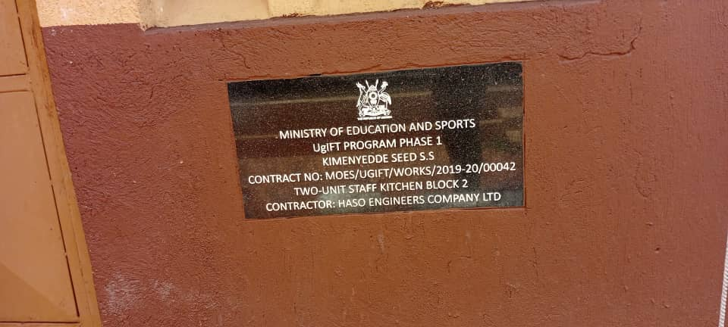
2. | Identification plaque on the 2 classroom block S3&s4 | 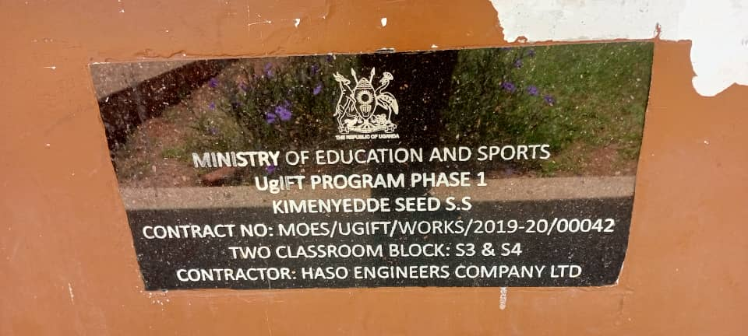
3. | Identification plaque on the 2 unit science laboratory block | 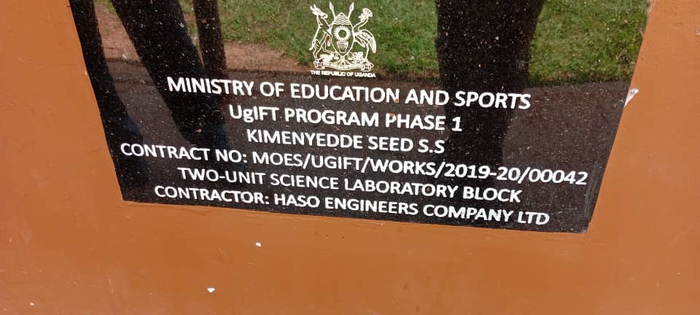
4 | Identification block on the 2 classroom block S5 & S6 | 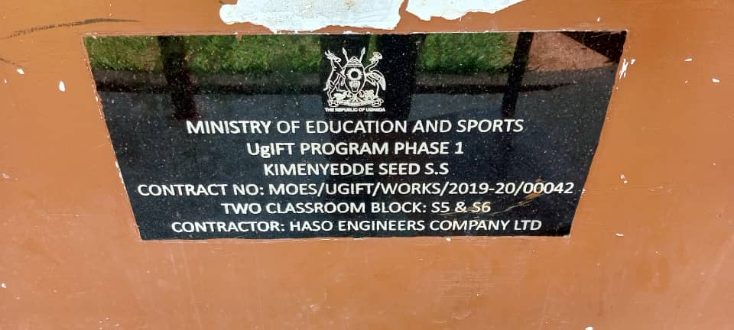
5. | Identification plaque on the 2 stance VIP latrine block 2 | 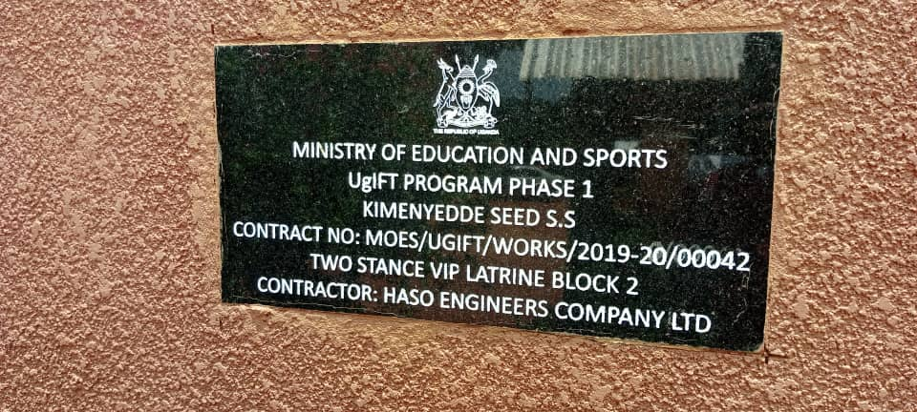
6. | Identification plaque on the 2 unit staff house block 2 | 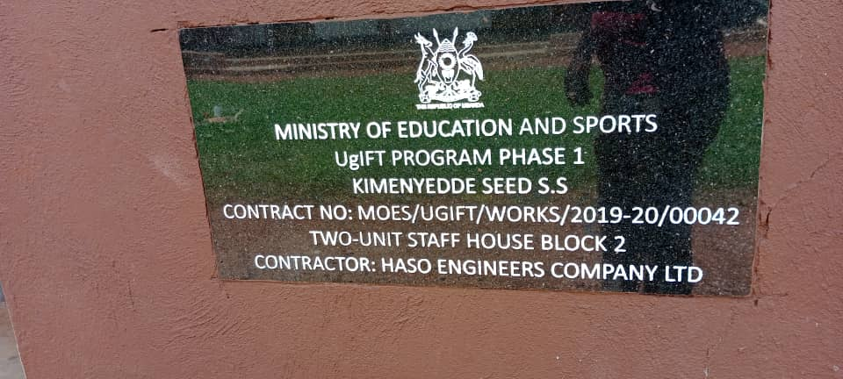
7 | Identification plaque on the administration block | 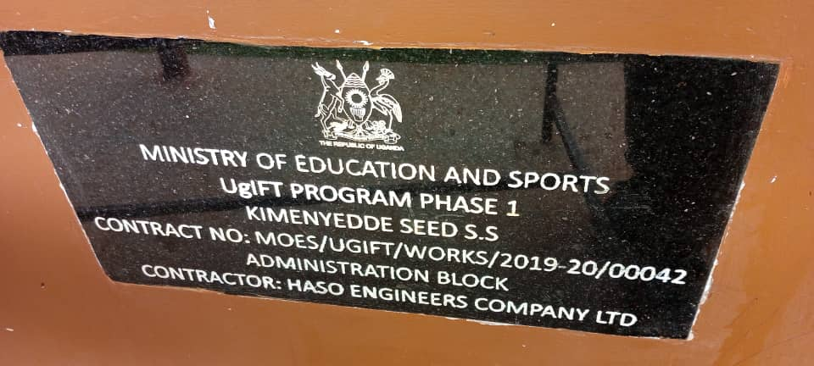
8. | One of the stools in the laboratory provided by the program | 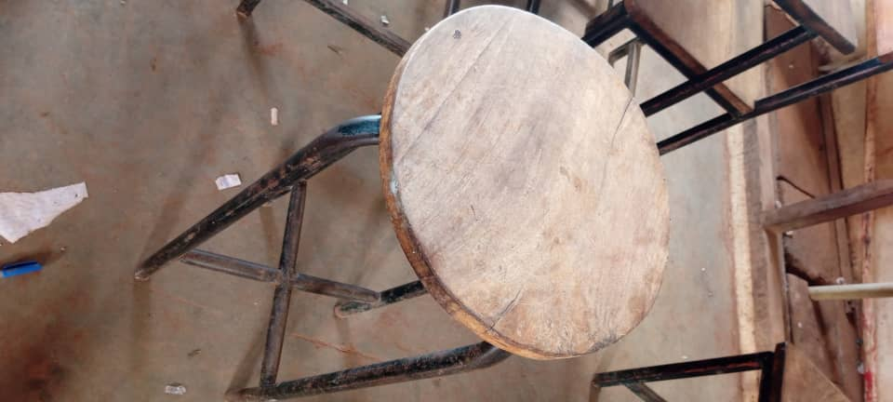
9. | Identification plaque on the boys’ 5 stance VIP latrine | 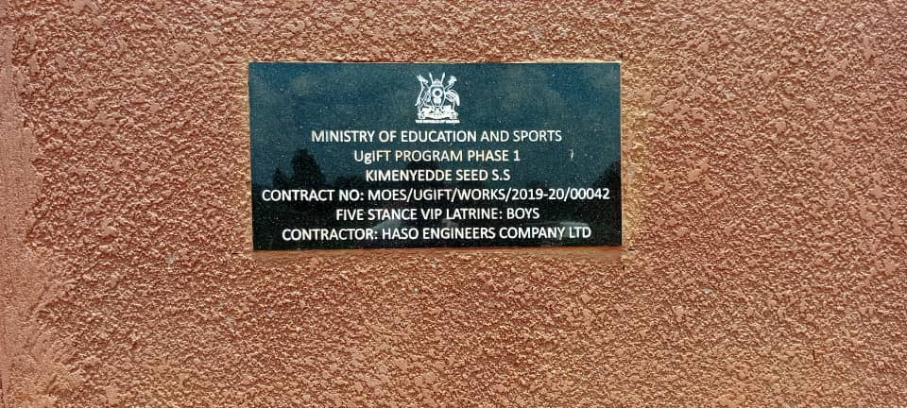
10. | Identification plaque on the 2-classroom block for s1 & S2 | 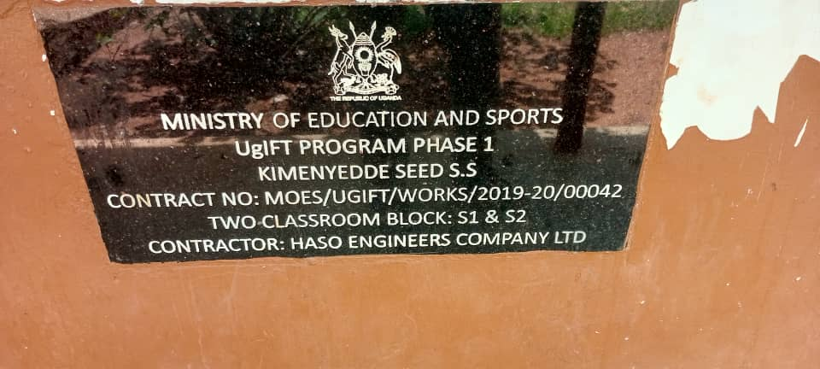
11 | Identification plaque on the ICT/Library block | 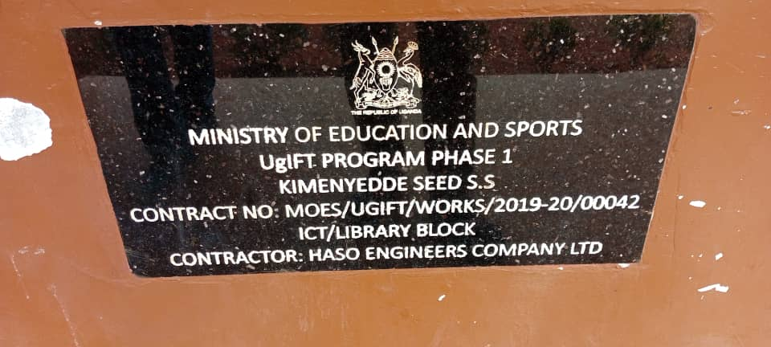
12. | Identification plaque on the 2 stance VIP latrine block 3 | 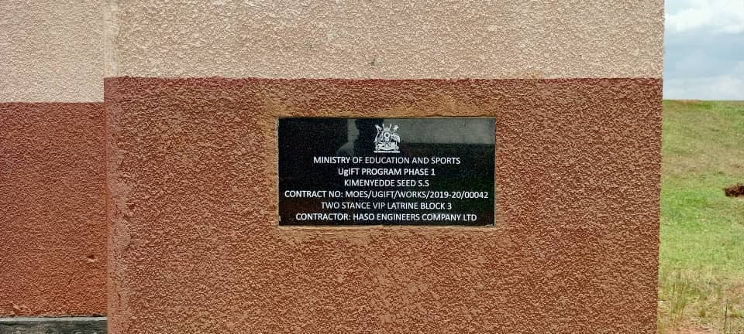
13 | An engraved computer set | 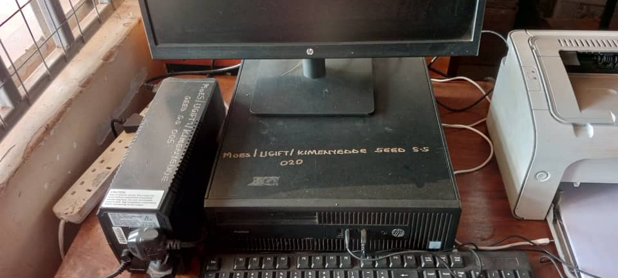
14 | Identification plaque on the multi-purpose 3 classroom block | 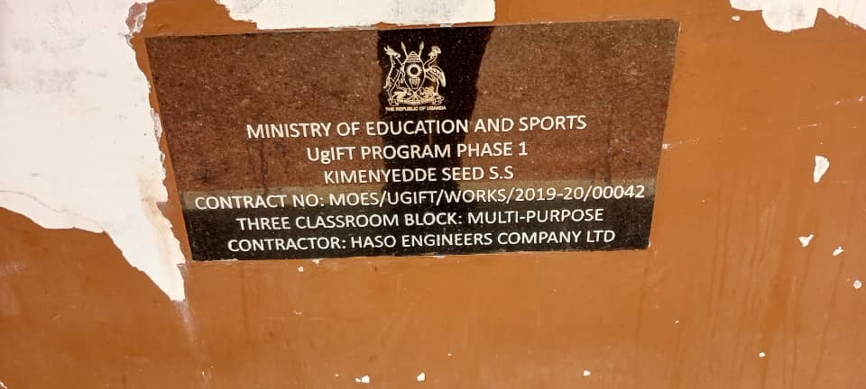
15 | A 10000-water liter tank | 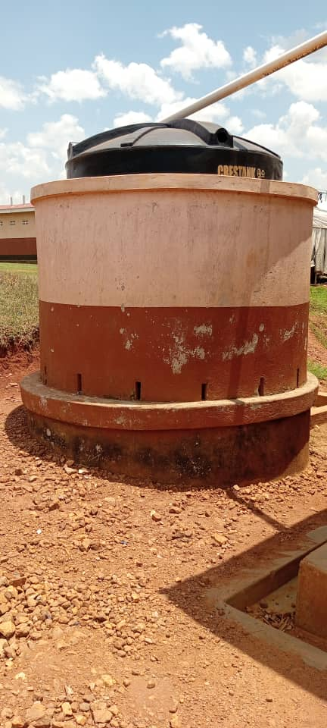
16 | An identification plaque on the 2 stance VIP latrine on the administration block | 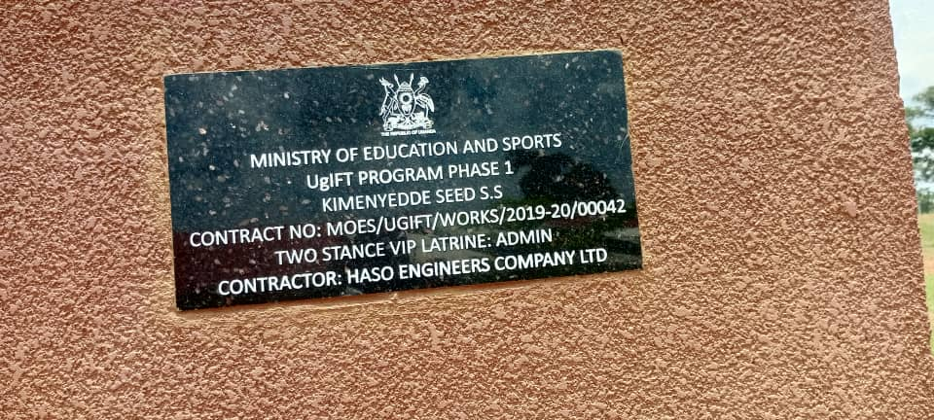
17 | A sign post of the then ongoing school project | 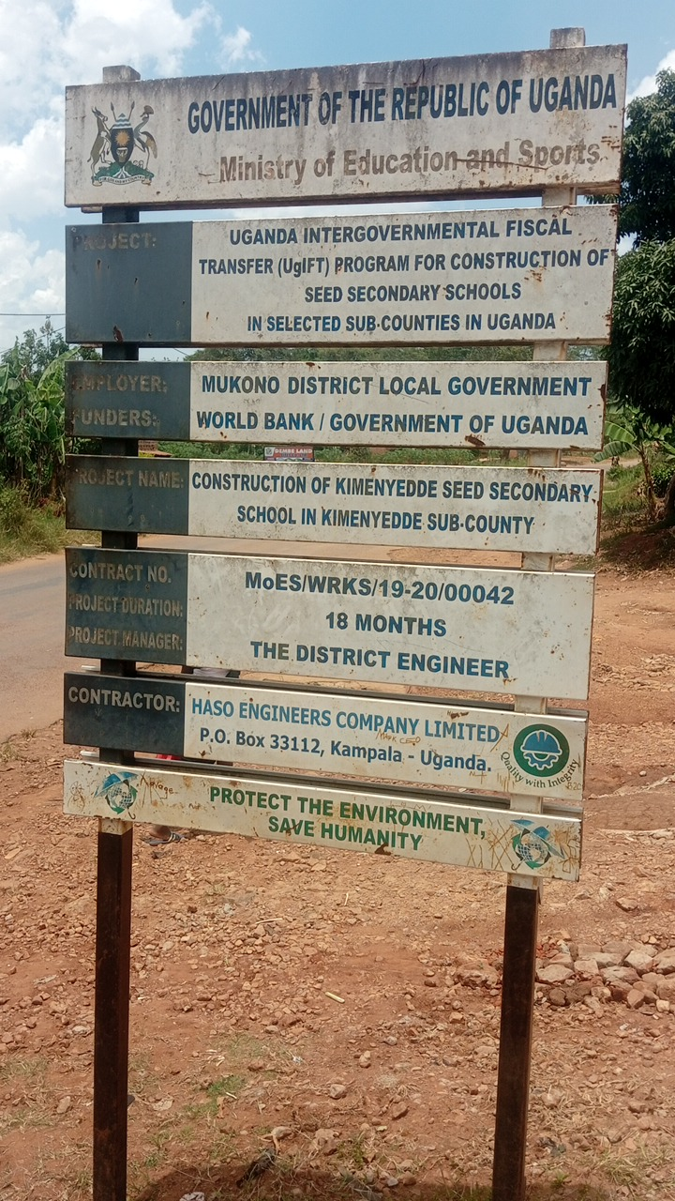
18 | A signage of the school location | 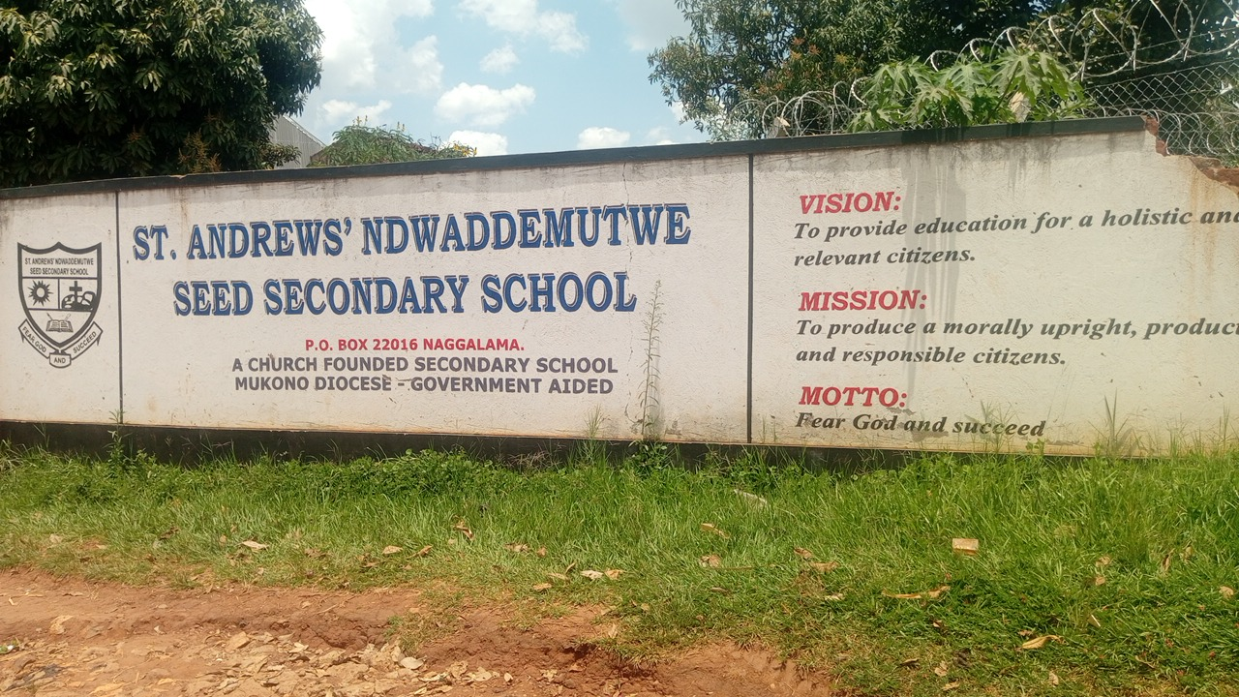
19 | Computer laboratory | 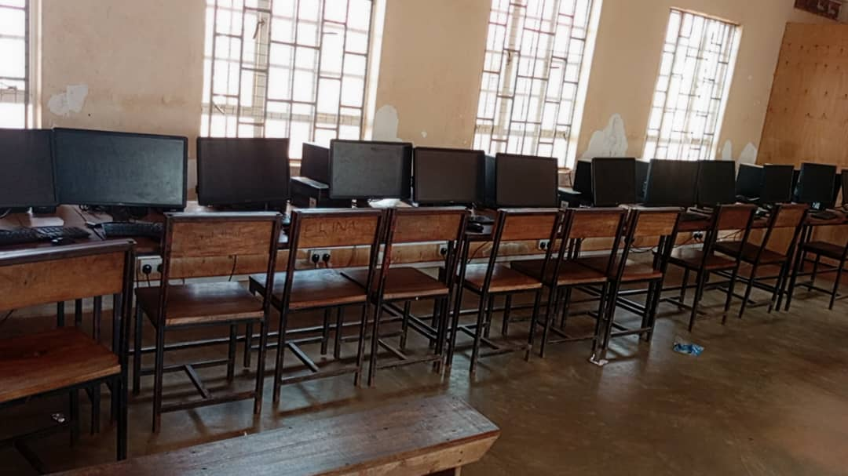
20 | One of the toilet facilities | 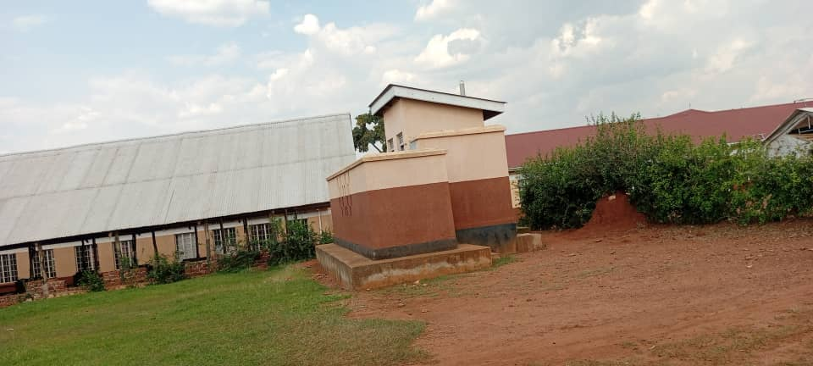
21 | 2 unit staff house | 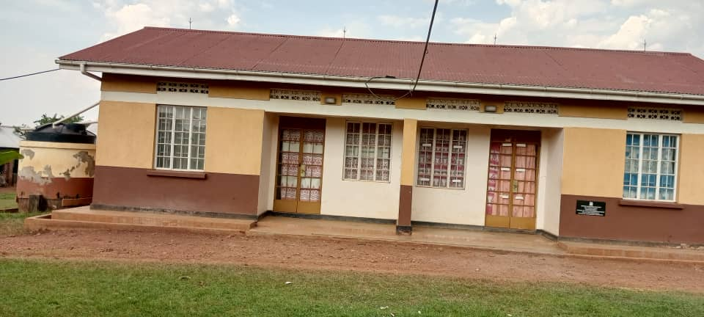
22 | A toilet facility and a classroom block | 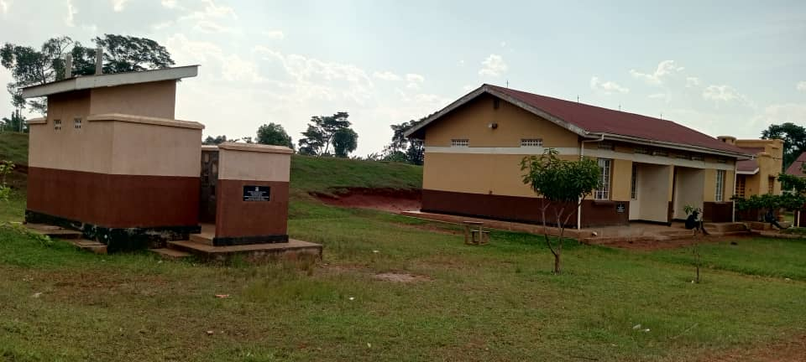
23 | An S2 & S3 Classroom block | 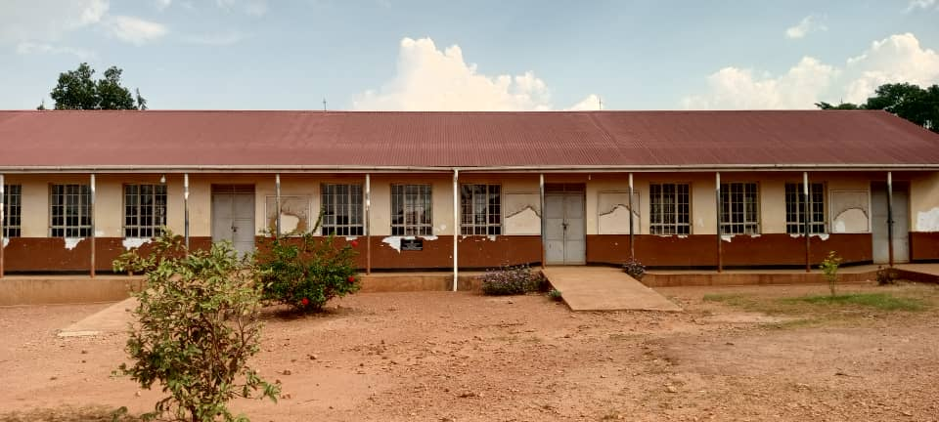
24 | A classroom setting consisting some of the wooden tables and chairs with metallic stands | 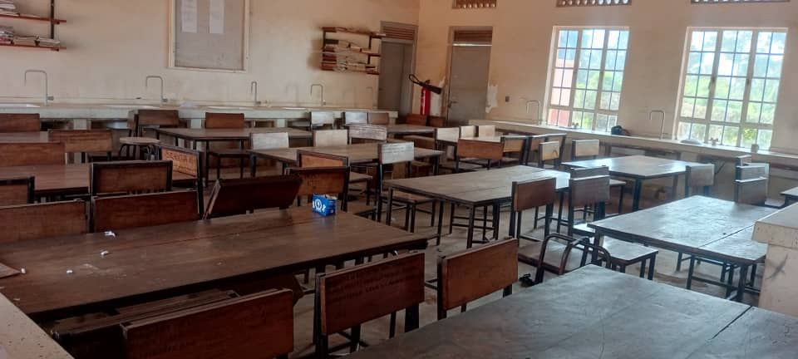
25 | Classroom block | 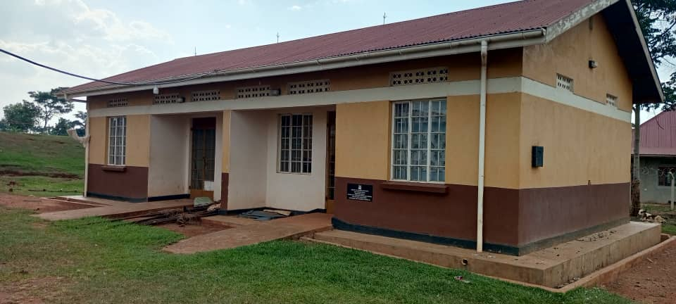
26 | Wooden book shelves in the library | 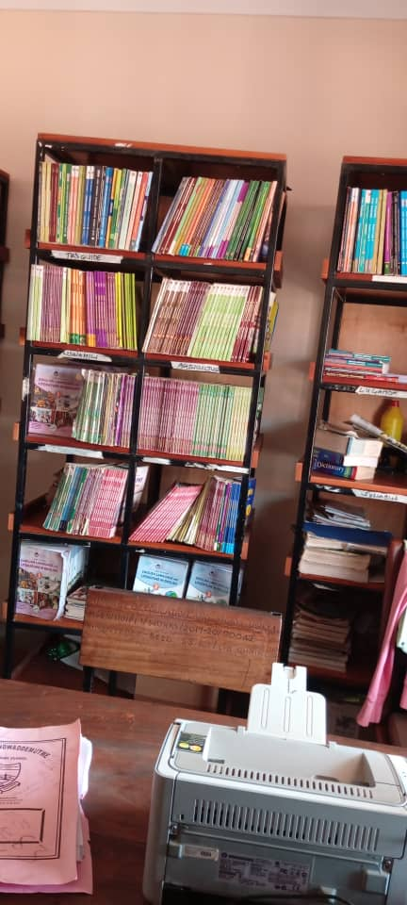
27 | The toilet facilities | 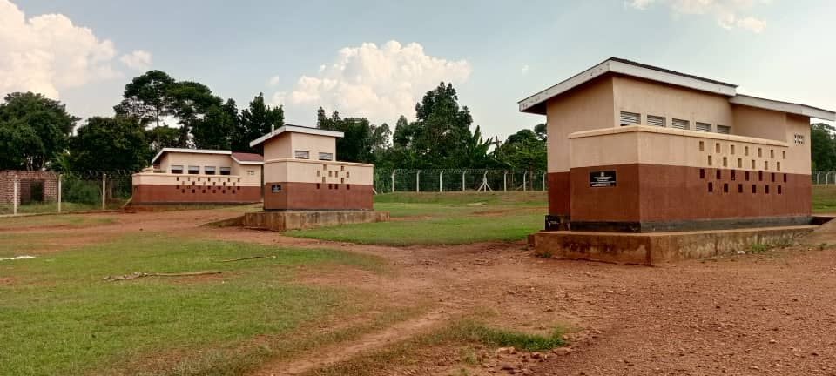
28 | Science laboratory with wooden chairs, tables and a fire extinguisher | 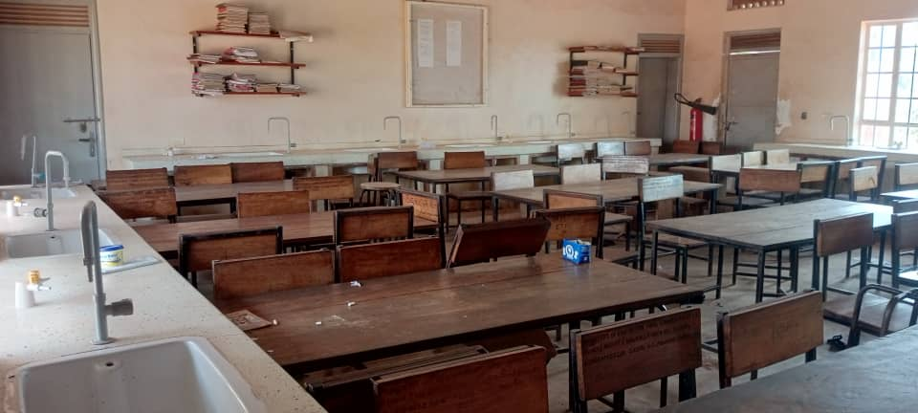
29 | Classroom block | 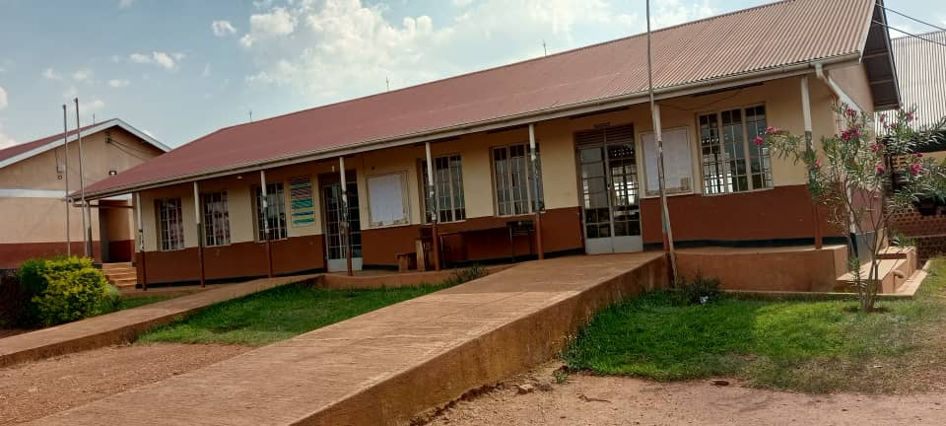
30 |  | 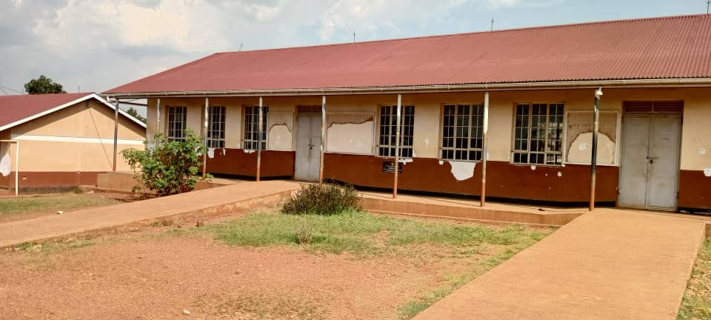
31 | Administration block | 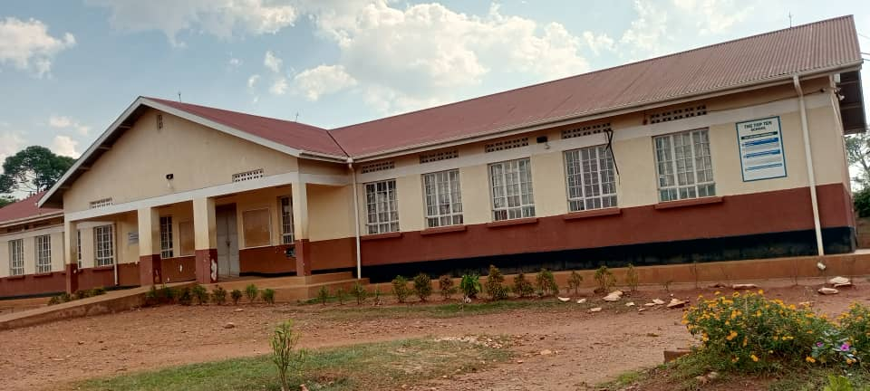
32 | The S5 & S6 Classroom block | 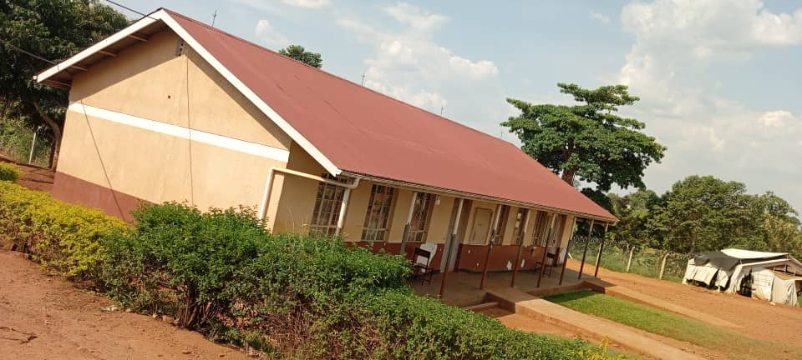
33 |  | 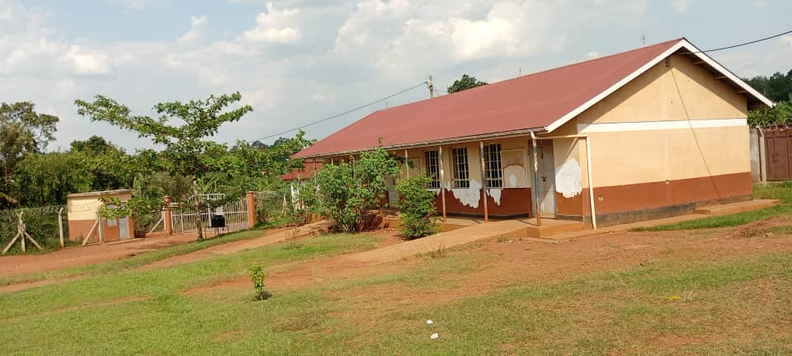
34 | The 2 water tanks received under the program | 